# Create A Pinned Conference

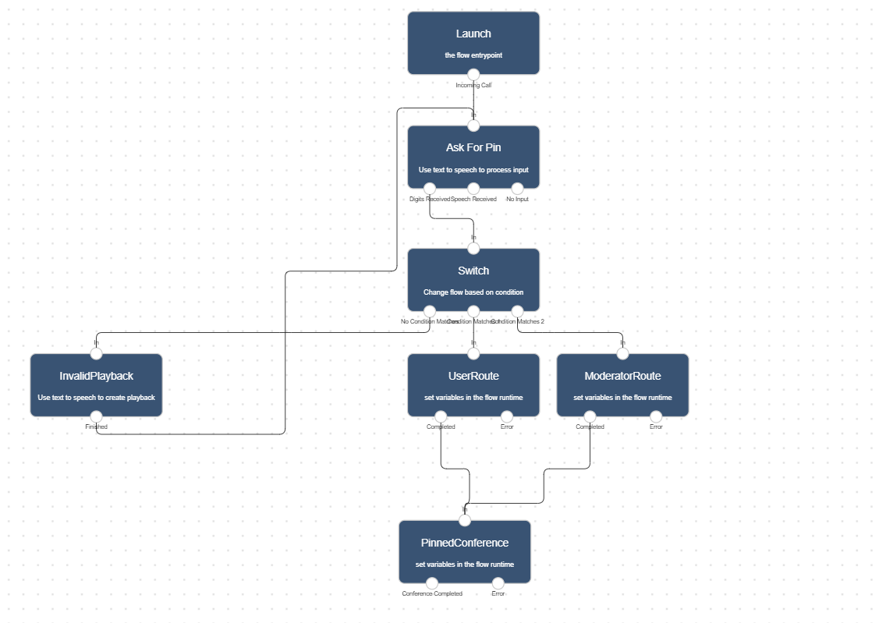

Pinned conferences allow you to create discussion rooms you and your team can access on demand. A basic pin conference usually includes an assigned number of members and a set of access pins your team members can use to access the conferencing room.

In Lineblocs, you can entirely create basic and advanced pinned conferences and customize conferencing workflows as per your needs.

This tutorial will go over how to create an essential pin-based conference using the Lineblocs flow editor.

## Getting Started

1. In [Lineblocs dashboard](https://app.lineblocs.com/" \l "/dashboard) click "Create" -> "New Flow"
2. Enter a name for your flow
3. Select the "Pin Conference" template
4. Click "Create"

## Add Pin Numbers

By default, the conference will be set up with default pins for moderator and user access.

To update the pin numbers used for your conference, please click the "Switch" widget to bring up its options, then open the "Links" tab.

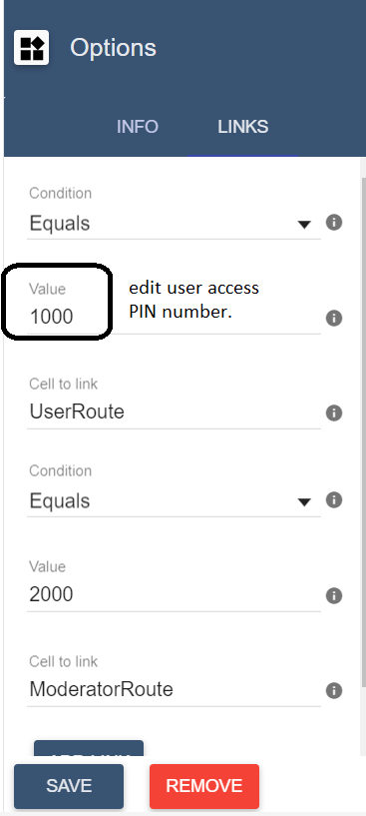

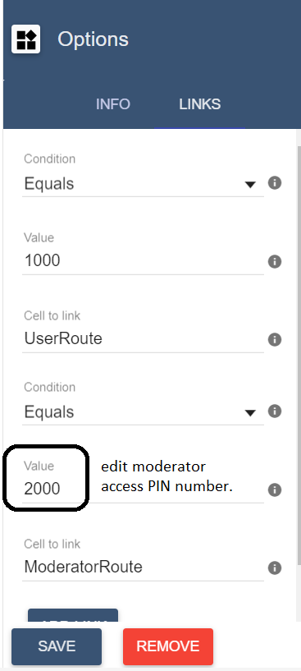

## Conference Settings

By default, the pinned conference will wait for a moderator to join, end when the moderator leaves as well as only allow up to 10 participants maximum on the call at any given time.

To update settings for your conference please open the “PinConference” widget.

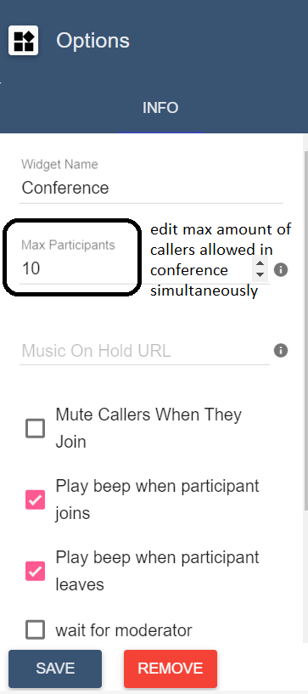

#### Moderator Access

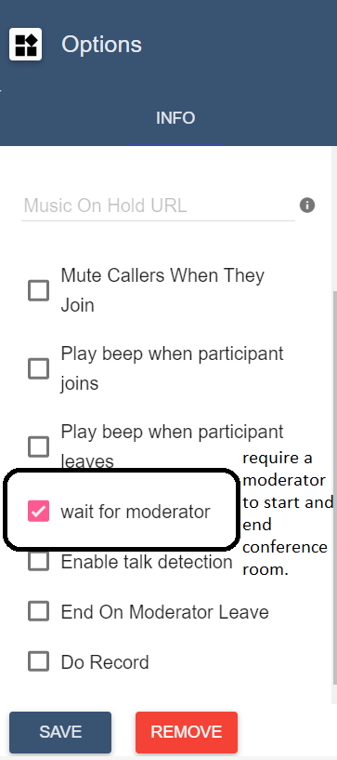

#### Notifications

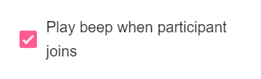

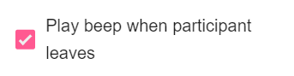

#### Speech Detection



## Using the flow on a DID number

To save all your changes please click IMG_264 in the flow editor.

To use your call flow on a DID Number:

1. In the lineblocs dashboard, please click [DID Numbers -> My Numbers](https://app.lineblocs.com/#/dashboard/dids/my-numbers)
2. Click the "Edit" button next to your number
3. Update the "Attached Flow" field
4. Click "Save"

## Testing the flow

Your team members should now be able to join conference calls using your DID number. To test your conference as a moderator or a user you can call the DID number you setup the conference flow on.

## Next Steps

In this guide, we discussed setting up pin-based conference. for other related quickstart posts, please see the guides below:

[Call Queues](https://lineblocs.com/resources/quickstarts/call-queues)

[Voicemail and Recordings](https://lineblocs.com/resources/quickstarts/recordings-and-voicemail)